Steps to submit paper

1. Login the conference website (http://www.iccrem.com/en/index.php)

with your own Username and Password, press "login"button.
2. Then enter into a new page, press the "Abstract" button on the left of page.
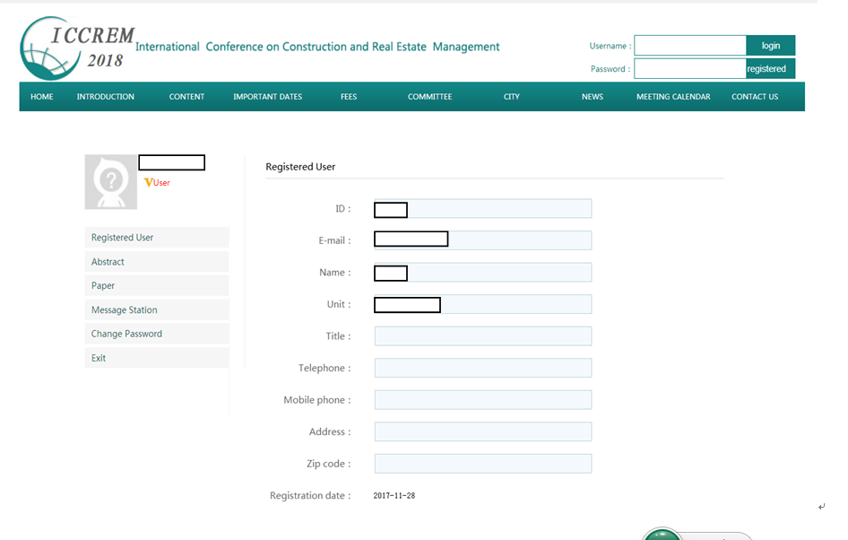
3. Enter into Upload papers page, press the " Upload papers ".

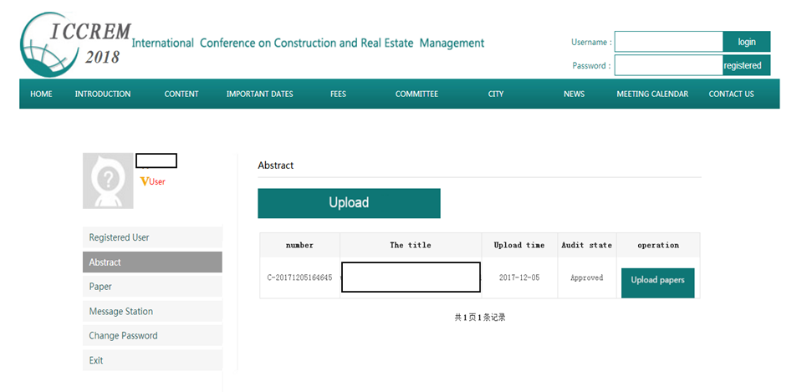

4. Enter into submit page, press "upload "button first to select your file, then press "Submit" button. OK !
